PHC 67/2020

TENDER AWARDED

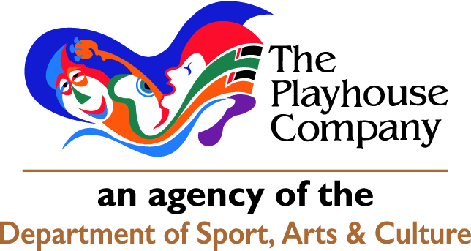

The KwaZulu-Natal Performing Arts Company
Declared in terms of section 3(1) of the Cultural Institutions Act, 1998(Act No 119 of 1998) on 01 April 2003

PO Box 5353, DURBAN, 4000, 29 Acutt Street, DURBAN, 4001, KwaZulu-Natal, South Africa

Tel: (031) 3699555, Fax: (031) 306 2166, Production Services Mayville, Tel (031) 208 4171 Fax: (031) 208 4162

http://www.playhousecompany.com

BID FOR: CLEANING SERVICES AT THE PLAYHOUSE COMPANY PREMISES FOR A PERIOD OF 3 YEARS.

Tender Start Date : 27 November 2020

Tender Close Date : 04 December 2020

Tender Award Date : 26 February 2021

Document received from the following bidders:

1. Feedem
2. Fidelity Cleaning Services
3. Great Purpose Enterprise
4. Hygeia Total Hygiene Solutions
5. Ikhayelihle Cleaning
6. Imvula Quality Protection
7. International Facilities Services
8. Kusile Facilities Management
9. Livclean
10. Maphuphu Trading
11. Marshall Cleaning
12. Meando Holdings
13. M-Jnr and Olwethu Consulting
14. National and Global Provider
15. NKL Medical Services
16. Ntumbesa Holdings
17. Quatro Cleaning
18. Red Alert
19. S.B Generation
20. Servest
21. Shanti Africa Security & Hygiene
22. Sibongelani Cleaning & Construction
23. Sonqoba Consultants
24. Syayithanda SA Pty Ltd
25. Tsebo Solutions
26. Vumanawe General Trading
Tender Awarded to:

Livclean (Pty) Ltd

